Our Scenario:

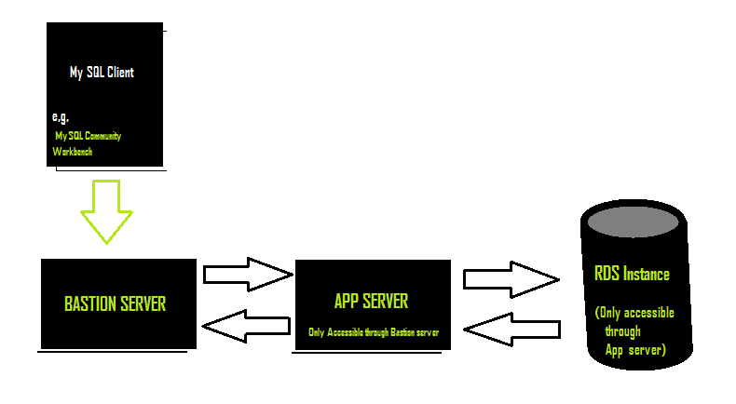

***To connect to RDS instance, two levels of SSH tunneling needs to be created:***

1. Firstly, a tunnel between Bastion Server and RDS instance through the App Server.
2. Secondly, connect MySQL client to Bastion Server using SSH tunneling option on MySQL workbench Community Edition.

Both the steps are described below:

***STEP 1: Creating a tunnel between Bastion Server and RDS instance through the App Server****.*

1. SSH to your Bastion instance and type the following command to create a tunnel between RDS instance and App server.

ssh **–N –L** 3307:<RDS ENDPOINT>:3306 <User Name>@<IP of APP Server>

Parameters:

|  |  |
| --- | --- |
| **-N** | *only set up the tunnel* |
| **-L** | *set up the forwarding* |
| **3307** | *port on your* ***local*** *machine* |

If above command is executed properly then you’ve successfully created a ssh tunnel!!!

Now, we’ll try to access the database through this tunnel.

1. Create a duplicate session of the above session and run the following command to connect to MySQL (Checking whether tunnel is created successfully).

mysql -u <Db-Username> -p -h 127.0.0.1 -P 3307

Parameters:

|  |  |
| --- | --- |
| **-u** | Username for database |
| **-p** | Database is password protected. Will ask for password later |
| **-h** | Host will be 127.0.0.1 always |
| **-P** | Port on which database is hosted |

***STEP 2: Connecting MySQL work bench client to RDS via the Bastion Server****.*

Open MySQL workbench and click on new connection.

Configure new connection as shown below:

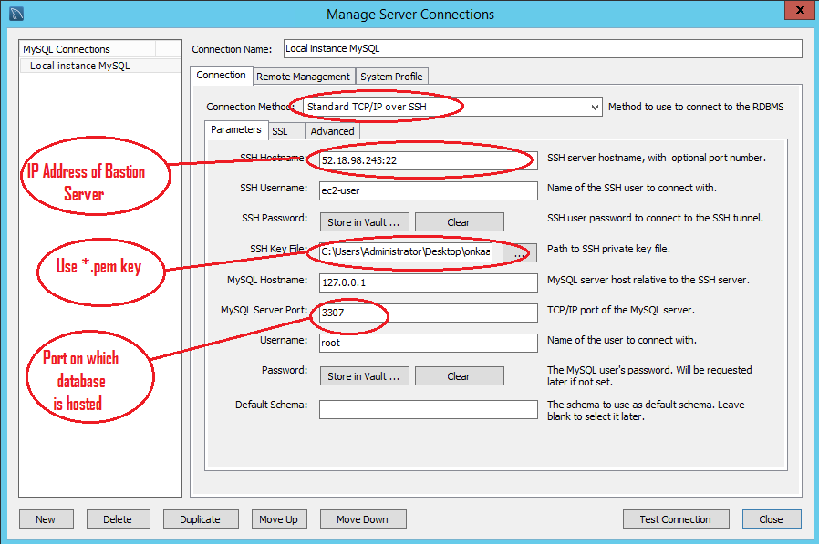

Click on Test connection to check if you are successfully connected to the database.